Autonomous Mobility: Future Last-mile Delivery

Kaiqiang Zheng   
Department of Engineering Technology  
McMaster UniversityHamilton, Canada  
zhengk15@mcmaster.ca  
  
Yujiong Chen  
Department of Engineering Technology  
McMaster UniversityHamilton, Canada  
@mcmaster.ca

***Abstract*—Urban logistic problems have intensified due to the rapid increase of e-commerce with all its associated delivery challenges including increasing traffic congestion, safety fears and growing carbon emissions. The article presents a holistic approach to solving these pressing questions by integrating autonomous mobility technologies in the last mile of the distribution system. This is done to improve last-mile delivery, minimize city traffic, provide a green environment and make our transport safer.**

**The project aims at using autonomous mobility on last-mile delivery based on the cutting edge of autonomous driving and machine learning technologies. In addition, incorporating smart city solutions supported by IoT sensors and algorithmic optimization will be aimed at getting optimal delivery approaches such as timing, routes, trucks and landing points.**

**Prospective results comprise alleviation of traffic congestion due to optimized routes and schedules for a fully automated last-mile distribution system. Through the use of electronic and self-driven trucks, it is expected that the project will reduce greenhouse gases and air pollution in an attempt to conserve the environment. Autonomous delivery vehicles operating around the clock are supposed to provide much better performance and decrease customer waiting time. In addition, modern safety elements embedded into autonomous cars are meant to reduce the number of accidents caused by people.**

**The multi-faceted programme is designed to improve urban logistics through the incorporation of autonomous mobility in last-mile delivery and provide urban planning guidelines to different cities on best practices for embracing autonomous mobility It would ensure a smoother supply chain, lower traffic jams, fewer toxic emissions, enhanced efficiencies, and better urban life.**

***Keywords—*autonomous mobility*,* traffic congestion*,* carbon emissions*, Safety,* electronic and self-driven trucks *(****key words****)***

# Introduction (*Heading 1*)

The last mile of delivery has become a crucial bottleneck of the supply chain under the influence of rapid urbanization and expanding e-commerce. Many cities globally face problems associated with delayed deliveries, congested roadways, safety issues, and efforts to control CO2 emissions in the air. Recognizing the urgency of addressing these issues, our project, titled "Autonomous Mobility: The project, “Future Last Mile Delivery,” is meant to transform urban logistics as well as sustainability in the provision of last-mile delivery services.

The expanding e-commerce world and its associated delivery service have necessitated more traffic in our cities thereby causing traffic jams. Autonomous electric cars can help deal with congestion problems leading to shorter trips for residents and less damage to roads.

The heart of our efforts includes environmental sustainability. Our goal is to create an efficient and green self-driving electric car fleet which will help cities fight against global warming by greening their urban areas. The city must be greenhouse gas emission conscious and climate change adaptive to reduce its carbon footprint.

Our project also pays attention to the issue of safety. Autonomous vehicles will deliver better safety at the expense of reduced human error. The provision of safety features in these automobiles could highly enhance the security of both the delivery company’s couriers as well as others who might be pedestrian users on the road.

## *Motivation behind the project*

● Efficiency in Last Mile Delivery: In many cases, the supply chain's final mile delivery is the most costly and time-consuming link. Solutions for autonomous mobility can streamline this procedure by cutting expenses, delivery times, and transportation's negative environmental effects.

● Traffic Congestion: As e-commerce and delivery services have grown, urban regions are experiencing increased traffic congestion.

● Environmental Sustainability: Reducing last-mile delivery's carbon footprint is critical to the fight against climate change. A cleaner, more sustainable city can be achieved by designing autonomous electric vehicles that use less energy and produce fewer greenhouse emissions.

● Safety: The number of accidents brought on by human error may be decreased by autonomous cars.

● Autonomous package delivery methods: With the development of autonomous driving technology and machine learning algorithms, autonomous driving vehicles and drones could be one of the solutions to urban delivery issues.

● Smart city solutions: Possible implementation of city IoT sensors, using algorithms to generate best delivery approaches (time, route, vehicle, package drop-off locations).

## *Purpose of research*

● Reduced Traffic Congestion: By optimizing routes and timetables, autonomous last-mile delivery systems can help cities experience fewer traffic jams. Residents commute more quickly as a result, and the infrastructure experiences less wear and tear.

● Lower Emissions: The initiative can assist in lowering greenhouse gas emissions and air pollution by utilizing electric and driverless vehicles.

● Enhanced Efficiency: Autonomous delivery vehicles can operate 24/7, improving delivery efficiency and reducing customer waiting times.

● Improved Safety: Autonomous vehicles are equipped with advanced safety features, reducing the risk of accidents caused by human error

Our visions go outsmart smart city solutions, not limiting only to intelligent vehicles. Integration citywide of IOT sensors along with advanced algorithms to offer the best approach for timing day, routing, vehicles and delivery packages at their destination. This is a whole concept implying that there will be a comprehensive last-mile delivery system and one smart city in the making.

What is more, our project brings immense benefits and outcomes. It revolutionizes urban logistics by cutting down on road jams, reducing CO2 emissions, enhancing delivery performance and ensuring safety. In this century, we will make our cities sustainable, efficient and resilient with the assistance of autonomous mobility for last-mile delivery.

# Problem Statement & Discussion

## *CO2 Emissions*

## The adverse environmental effects are evident, with elevated levels of air pollution and greenhouse gas emissions exacerbating urban pollution and contributing to climate change.The emissions of excess amounts of CO2 do a lot of damage to the environment and also to people. The greenhouse effect involves high levels of carbon dioxide which traps heat back into the atmosphere leading to global warming. In addition, high carbon dioxide concentration worsens air pollution, especially in the context of developed countries with already dense air pollution that leads to a high incidence rate of respiratory disease and most importantly global warming which is associated with the contribution from transportation networks. It is more than an environmental concern, and has a bearing on the overall health of urban dwellers.

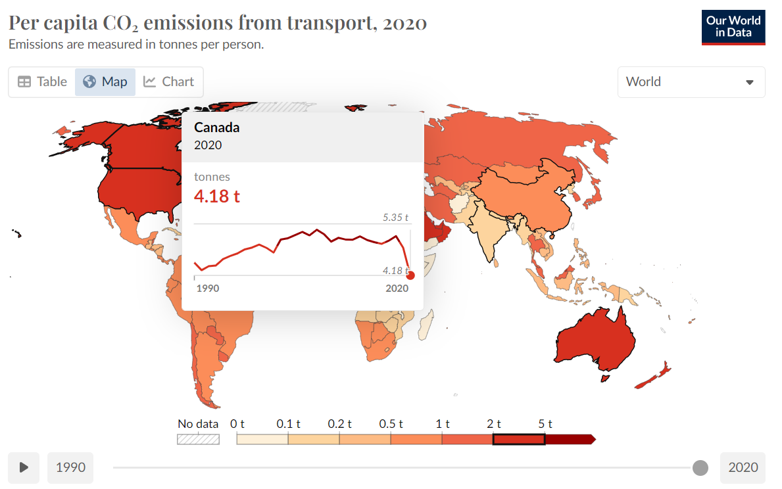

Figure 1. Per capita CO₂ emissions from transport, 2020 [1][4]

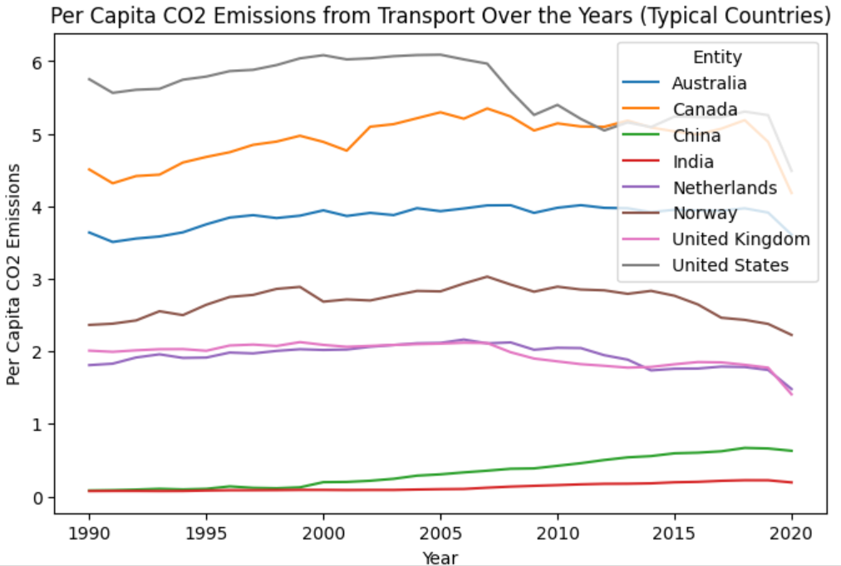

Figure 2. Per capita CO₂ emissions from transport over the years in Australia, Canada, China, India, Netherlands, Norway, United Kingdom, United States, 2023 [1][4]

Figure 2 shows the per capita CO₂ emissions from transport over the years in Australia, Canada, China, India, Netherlands, Norway, United Kingdom, and United States, projected up to 2023. The graph indicates that the United States has consistently had the highest per capita CO₂ emissions from transport, followed by Canada and Australia. According to Figure 1&2, Canada has a relatively high per capita CO₂ emission at 4.18 tonnes per person in 2020 from transport compared to the world. [1]

Autonomous Mobility for Future Last Mile Delivery is determined to catalyze action in tackling CO2 emissions. The goal is to lead the charge in building healthier and more sustainable cities. Implementing autonomous electric vehicles aims to make a significant impact on reducing the carbon footprint of last-mile delivery, ultimately creating a more resilient urban ecosystem.

## *Safety Issues*

## The strain on transportation networks can lead to a decline in overall road safety, as congested conditions often correlate with a higher risk of accidents. Increasing security issues surrounding conventional last-mile delivery call for new models of operation. Another main cause of accidents is human error which causes a huge risk for the delivery operators themselves as well as the pedestrians. Safety worries regarding urban deliveries do not end with accidental impacts and they affect people’s attitude toward trusting city-based supply chains.

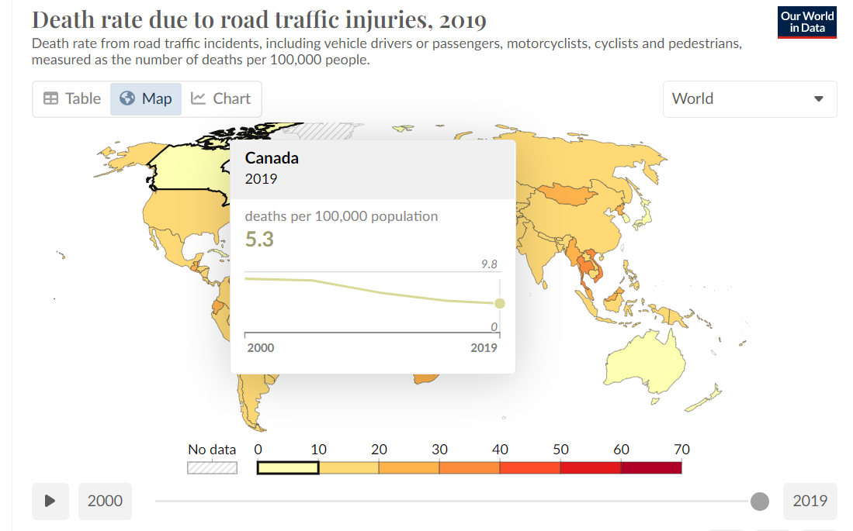

Figure 3.Death rate due to road traffic injuries (per 100,000 population), 2019 [2]

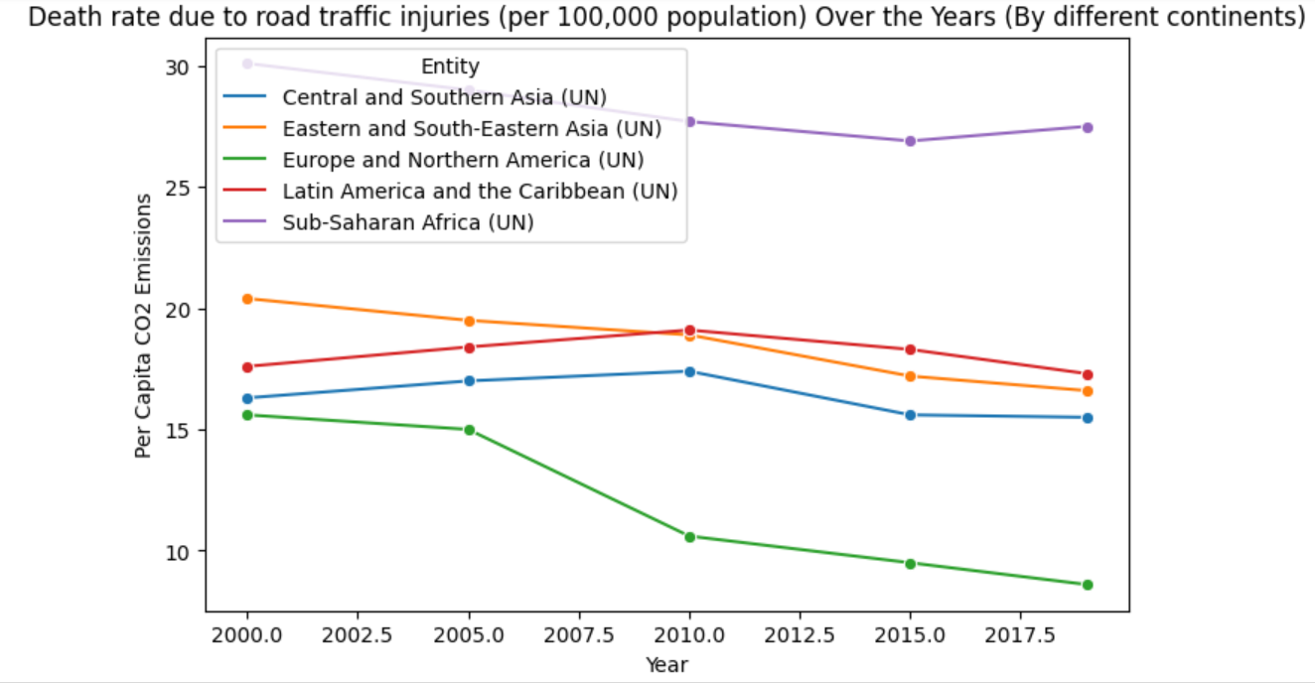

Figure 4.Death rate due to road traffic injuries (per 100,000 population) over years (In different continents), 2023 [2][4]

Regard to Figure 3, which shows the death rate due to road traffic injuries per 100,000 population in 2019. The figure highlights the significant impact of road traffic injuries on public health and safety, particularly in low- and middle-income countries. The death rate in Canada was much lower at only 5.3 per 100,000 population.[2]

In addition, in Figure 4, it is obvious that developing countries have a higher possibility of people getting injured from traffic accidents, such as Sub-Saharan Africa and Eastern Asia (Becoming better and better over the years).[2]

By incorporating advanced safety technology into autonomous vehicles, this project aims to not only decrease the frequency of accidents, but also cultivate a reliable and trustworthy last-mile delivery system. This proactive approach to safety has the potential to create a more secure urban environment by mitigating the risks associated with traditional delivery methods, ultimately prioritizing the well-being of residents.

## *Traffic congestion*

Traffic congestion is a problem which often occurs in cities and affects the everyday life of city residents everywhere. The increase in traffic due to the expansion of e-commerce and delivery services contributes to longer commute times, more fumed-up people and increased deterioration of city facilities. Besides creating traffic jams which stagnate the smooth flow of commodities and people, it implicates huge economic losses because of wastage in labour and fuel.

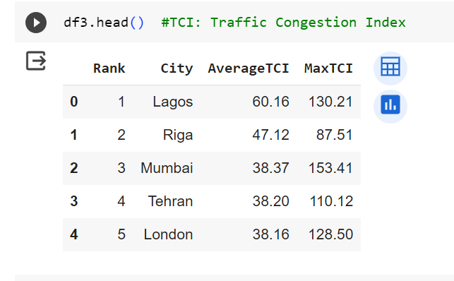

Figure 5.Top 5 Cities with High Average TCI, 2022 [3][4]

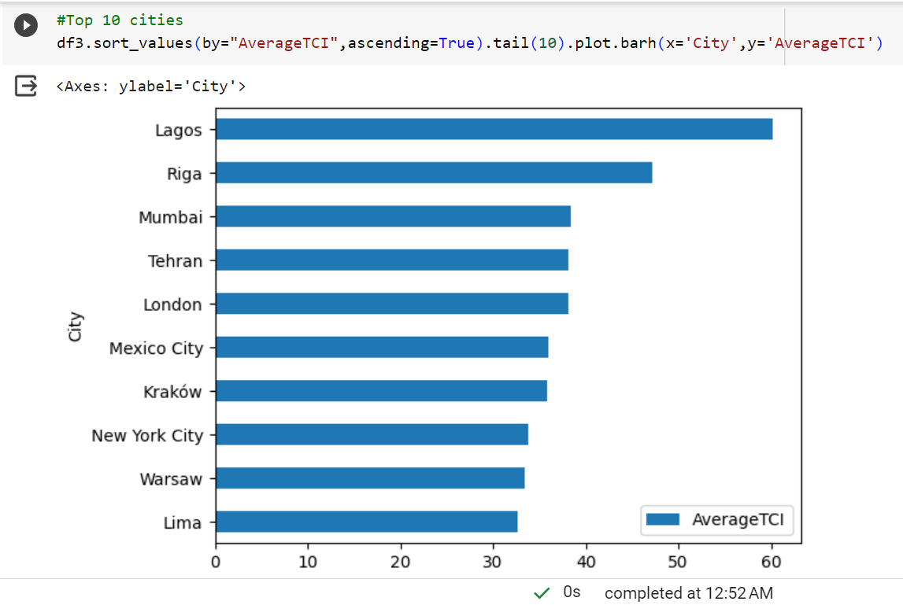

Figure 6.Top 10 Cities with High Average TCI, 2022 [3][4]

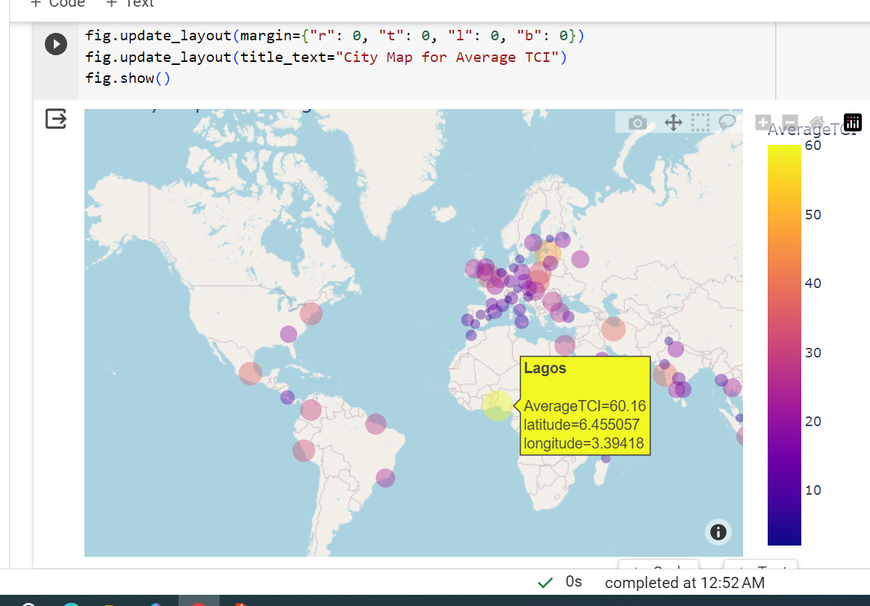

Figure 7.Global map of TCI, 2022 [3][4]

According to Figures 5 & 6 & 7 , display the top 10 cities with the highest average TCI across the world in 2022, Traffic Congestion Index. The most problematic traffic jam occurs in Lagos. Lagos, which is heavily affected by traffic jams, achieved the highest rating of TCI at about 60.16, followed by Riga at 47.12 and Mumbai at 38.37.[3][4]

Lagos is among the world's most crowded cities. In Nigeria, Lagos is where 40% of all car registrations are located. Every day, commuters endure at least three hours of traffic. For Lagos residents, traffic congestion causes a variety of issues. For instance, Lagos has a fatal accident rate of 28 per 100,000 residents. Compared to most cities in Europe, this is three times bigger. Additionally, air pollution exceeds the permissible limit by more than five times. [5]

# Methodology

Before you begin to format your paper, first write and save the content as a separate text file. Complete all content and organizational editing before formatting. Please note sections A-D below for more information on proofreading, spelling and grammar.

Keep your text and graphic files separate until after the text has been formatted and styled. Do not use hard tabs, and limit use of hard returns to only one return at the end of a paragraph. Do not add any kind of pagination anywhere in the paper. Do not number text heads-the template will do that for you.

## *Abbreviations and Acronyms*

Define abbreviations and acronyms the first time they are used in the text, even after they have been defined in the abstract. Abbreviations such as IEEE, SI, MKS, CGS, sc, dc, and rms do not have to be defined. Do not use abbreviations in the title or heads unless they are unavoidable.

## *Units*

* Use either SI (MKS) or CGS as primary units. (SI units are encouraged.) English units may be used as secondary units (in parentheses). An exception would be the use of English units as identifiers in trade, such as “3.5-inch disk drive”.
* Avoid combining SI and CGS units, such as current in amperes and magnetic field in oersteds. This often leads to confusion because equations do not balance dimensionally. If you must use mixed units, clearly state the units for each quantity that you use in an equation.
* Do not mix complete spellings and abbreviations of units: “Wb/m2” or “webers per square meter”, not “webers/m2”. Spell out units when they appear in text: “. . . a few henries”, not “. . . a few H”.
* Use a zero before decimal points: “0.25”, not “.25”. Use “cm3”, not “cc”. (*bullet list*)

## *Equations*

The equations are an exception to the prescribed specifications of this template. You will need to determine whether or not your equation should be typed using either the Times New Roman or the Symbol font (please no other font). To create multileveled equations, it may be necessary to treat the equation as a graphic and insert it into the text after your ypaper is styled.

Number equations consecutively. Equation numbers, within parentheses, are to position flush right, as in (1), using a right tab stop. To make your equations more compact, you may use the solidus ( / ), the exp function, or appropriate exponents. Italicize Roman symbols for quantities and variables, but not Greek symbols. Use a long dash rather than a hyphen for a minus sign. Punctuate equations with commas or periods when they are part of a sentence, as in:

*a*  *b*    

Note that the equation is centered using a center tab stop. Be sure that the symbols in your equation have been defined before or immediately following the equation. Use “(1)”, not “Eq. (1)” or “equation (1)”, except at the beginning of a sentence: “Equation (1) is . . .”

## *Some Common Mistakes*

* The word “data” is plural, not singular.
* The subscript for the permeability of vacuum *μ*0, and other common scientific constants, is zero with subscript formatting, not a lowercase letter “o”.
* In American English, commas, semicolons, periods, question and exclamation marks are located within quotation marks only when a complete thought or name is cited, such as a title or full quotation. When quotation marks are used, instead of a bold or italic typeface, to highlight a word or phrase, punctuation should appear outside of the quotation marks. A parenthetical phrase or statement at the end of a sentence is punctuated outside of the closing parenthesis (like this). (A parenthetical sentence is punctuated within the parentheses.)
* A graph within a graph is an “inset”, not an “insert”. The word alternatively is preferred to the word “alternately” (unless you really mean something that alternates).
* Do not use the word “essentially” to mean “approximately” or “effectively”.
* In your paper title, if the words “that uses” can accurately replace the word “using”, capitalize the “u”; if not, keep using lower-cased.
* Be aware of the different meanings of the homophones “affect” and “effect”, “complement” and “compliment”, “discreet” and “discrete”, “principal” and “principle”.
* Do not confuse “imply” and “infer”.
* The prefix “non” is not a word; it should be joined to the word it modifies, usually without a hyphen.
* There is no period after the “et” in the Latin abbreviation “et al.”.
* The abbreviation “i.e.” means “that is”, and the abbreviation “e.g.” means “for example”.

An excellent style manual for science writers is [7].

# Conclusion

After the text edit has been completed, the paper is ready for the template. Duplicate the template file by using the Save As command, and use the naming convention prescribed by your conference for the name of your paper. In this newly created file, highlight all of the contents and import your prepared text file. You are now ready to style your paper; use the scroll down window on the left of the MS Word Formatting toolbar.

## *Authors and Affiliations*

**The template is designed for, but not limited to, six authors.** A minimum of one author is required for all conference articles. Author names should be listed starting from left to right and then moving down to the next line. This is the author sequence that will be used in future citations and by indexing services. Names should not be listed in columns nor group by affiliation. Please keep your affiliations as succinct as possible (for example, do not differentiate among departments of the same organization).

### *For papers with more than six authors:* Add author names horizontally, moving to a third row if needed for more than 8 authors.

### *For papers with less than six authors:* To change the default, adjust the template as follows.

#### *Selection:* Highlight all author and affiliation lines.

#### *Change number of columns:* Select the Columns icon from the MS Word Standard toolbar and then select the correct number of columns from the selection palette.

#### *Deletion:* Delete the author and affiliation lines for the extra authors.

## *Identify the Headings*

Headings, or heads, are organizational devices that guide the reader through your paper. There are two types: component heads and text heads.

Component heads identify the different components of your paper and are not topically subordinate to each other. Examples include Acknowledgments and References and, for these, the correct style to use is “Heading 5”. Use “figure caption” for your Figure captions, and “table head” for your table title. Run-in heads, such as “Abstract”, will require you to apply a style (in this case, italic) in addition to the style provided by the drop down menu to differentiate the head from the text.

Text heads organize the topics on a relational, hierarchical basis. For example, the paper title is the primary text head because all subsequent material relates and elaborates on this one topic. If there are two or more sub-topics, the next level head (uppercase Roman numerals) should be used and, conversely, if there are not at least two sub-topics, then no subheads should be introduced. Styles named “Heading 1”, “Heading 2”, “Heading 3”, and “Heading 4” are prescribed.

## *Figures and Tables*

#### *Positioning Figures and Tables:* Place figures and tables at the top and bottom of columns. Avoid placing them in the middle of columns. Large figures and tables may span across both columns. Figure captions should be below the figures; table heads should appear above the tables. Insert figures and tables after they are cited in the text. Use the abbreviation “Fig. 1”, even at the beginning of a sentence.

1. Table Type Styles

| **Table Head** | **Table Column Head** | | |
| --- | --- | --- | --- |
| ***Table column subhead*** | ***Subhead*** | ***Subhead*** |
| copy | More table copya |  |  |

1. Sample of a Table footnote. (*Table footnote*)
2. Example of a figure caption. (*figure caption*)

Figure Labels: Use 8 point Times New Roman for Figure labels. Use words rather than symbols or abbreviations when writing Figure axis labels to avoid confusing the reader. As an example, write the quantity “Magnetization”, or “Magnetization, M”, not just “M”. If including units in the label, present them within parentheses. Do not label axes only with units. In the example, write “Magnetization (A/m)” or “Magnetization {A[m(1)]}”, not just “A/m”. Do not label axes with a ratio of quantities and units. For example, write “Temperature (K)”, not “Temperature/K”.

##### Acknowledgment *(Heading 5)*

The preferred spelling of the word “acknowledgment” in America is without an “e” after the “g”. Avoid the stilted expression “one of us (R. B. G.) thanks ...”. Instead, try “R. B. G. thanks...”. Put sponsor acknowledgments in the unnumbered footnote on the first page.

##### References

[1]“Per capita CO₂ emissions from transport,” *Our World in Data*. https://ourworldindata.org/grapher/per-capita-co2-transport?stackMode=absolute%C2%AEion (accessed Nov. 19, 2023).

[2]“Death rate due to road traffic injuries,” *Our World in Data*. https://ourworldindata.org/grapher/death-rate-road-traffic-injuries?time=latest (accessed Nov. 19, 2023).

[3]koustubhk, “Worldwide Traffic Congestion Ranking,” *Kaggle*. https://www.kaggle.com/datasets/kkhandekar/worldwide-traffic-congestion-ranking/ (accessed Nov. 23, 2023).

[4]K. Zheng and Y. Chen, “Google Colaboratory,” *McMaster4SC3*, Nov. 22, 2023.https://colab.research.google.com/drive/1-SI2ISsVAEHRH-x7rWyxl6JuKe3KxRUg#scrollTo=TN4-SYlpuD9P (accessed Nov. 23, 2023).

[5]“Traffic Congestion in Lagos,” *Internet Geography*, Jan. 30, 2018. https://www.internetgeography.net/topics/traffic-congestion-in-lagos/#google_vignette (accessed Nov. 23, 2023).